MY REPORT STRUCTURE

Abdirahman Farah
[Student iD] 24796328
2025

1. CPU Simulation 1
1.1 Calculating the sum of values 1
1.2 Completing the stop instruction 2
1.3 Bitwise Operations 3
1.4 Amending the ALU 4
1.5 Output Device 7
1.6 Branch instruction 9
1.7 Loop 12
1.8 Game 13
2. RISC-V Assembly Language Programming 14
2.1 Test the existing program with minor adjustments 14
2.2 Improve the messages that the program outputs 14
2.3 Enhancing the functionality of the program 16
2.4 Adding a subroutine 17
2.5 Swapping Numbers 18
2.6 Counting down with a loop 21
2.7 Making use of arrays 21
2.8 Designing a game 22
3. References 23
4. Appendix A: The CPU Simulation Code 24
5. Appendix B: The RISC-V Assembly Language Code 26
5.1 Tasks 2.1 to 2.3 26
5.2 Task 2.4 Including a subroutine 27
5.3 Task 2.5 Swapping numbers 29
5.4 Task 2.6 Loop 31
5.5 Task 2.7 Array 31
5.6 Task 2.8 Creating a console based game 31
6. Appendix C: Use of Generative AI 32

CPU Simulation

Calculating the sum of values

Test data
The two test numbers are 63 and 28. In hexadecimal 63 is 3F and 28 is 1C.

Test program
v2.0 raw
103F 3000 # 1. put first value to ACC and address 00
101C 3001 # 2. put second value to ACC and address 01
2100 # 3. add ACC value to value from address 00
3002 # 4. store ACC value at address 02
f000 # 5. stop

Expected result
The sum is 5B in hexadecimal and 91 in decimal.

Circuit with program loaded

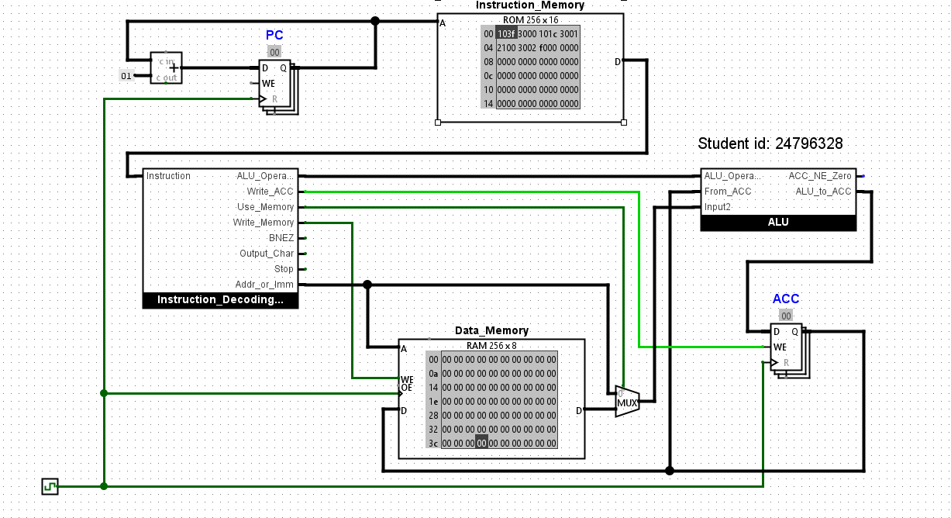
Circuit at end of program
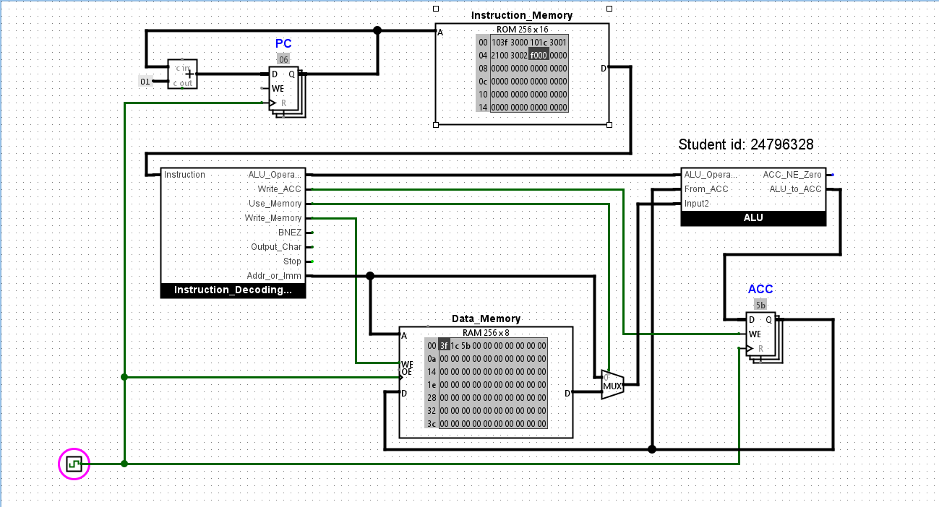

Result
The first three data-memory addresses now contain the two initial values and their total.

Completing the stop instruction

Circuit at start of Test
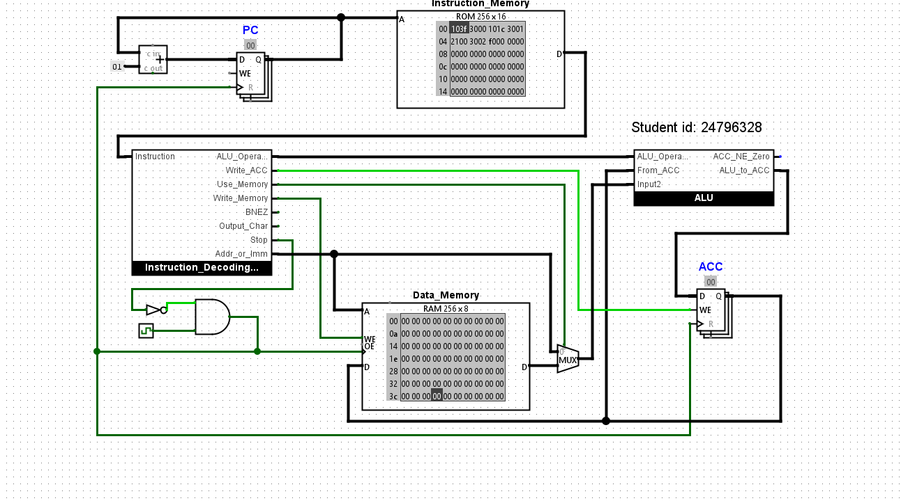

Circuit at end of Test
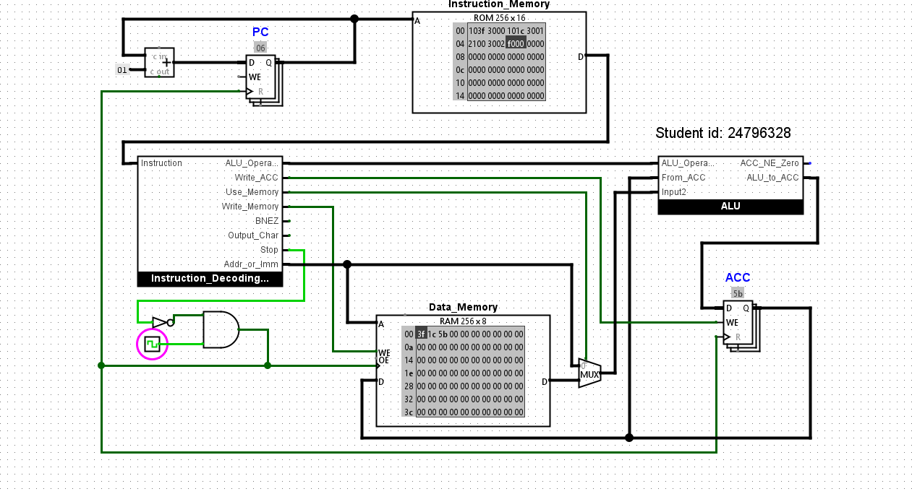

Explanation
The ACC, PC and Data Memory have a clock signal because they need to hold values and only change at the right moment each cycle, so the CPU stays in sync.

Bitwise Operations

Test program
v2.0 raw
103F 3000 # 1. put first value to ACC and store to 00
101C 3001 # 2. put second value to ACC and store to 01
2100 # 3. add ACC value to value from address 00
3002 # 4. store ACC value to address 02
2000 2201 # 5. load from 00 to ACC, bitwise NAND with value from 01
3003 # 6. store ACC value to address 03
2000 2301 # 5. load from 00 to ACC, bitwise NAND with value from 01
3004 # 6. store ACC value to address 04
f000

Expected result
 | binary | Hex
First number | 0011 1111 | 3F
Second number | 0001 1100 | 1C
Bitwise AND of original numbers | 0001 1100 | 1C
Bitwise NOT of previous result ( giving NAND) | 1110 0011 | E3
After bitwise OR of original numbers | 0011 1111 | 3F

Circuit at end of program
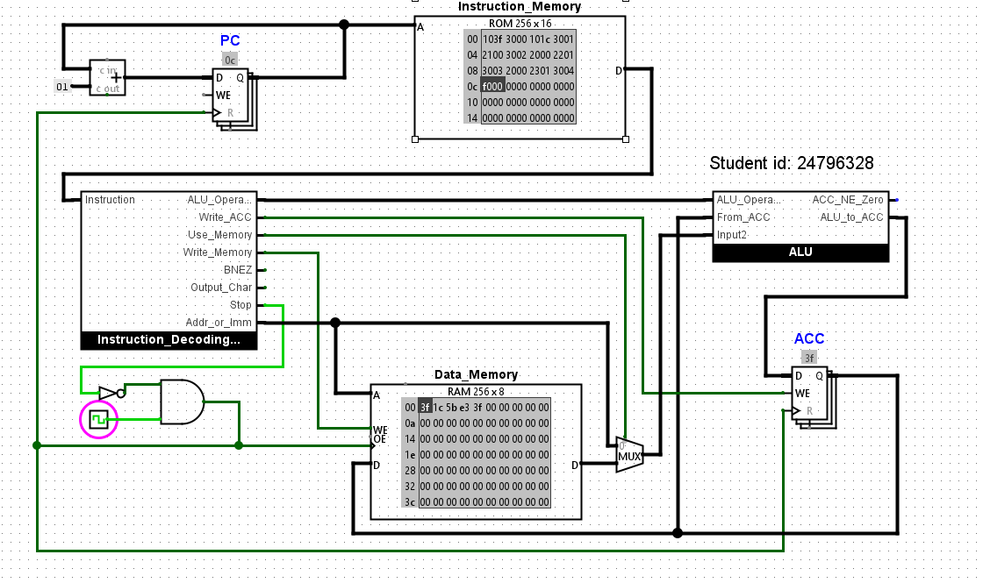

Result
In the data memory I now see an addition of E3 and also 3F showing now when before it stopped at 5B.

Explanation
OR sets each output bit to 1 if either input bit is 1, while NAND does AND then flips the result; the instruction decoder selects which ALU operation to perform.

Amending the ALU

ALU circuit
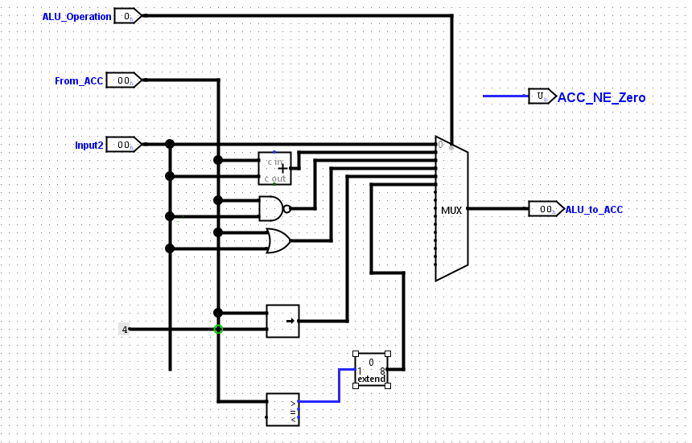

Test Program
v2.0 raw
103F 3000 # 1. put first value to ACC and store to 00
101C 3001 # 2. put second value to ACC and store to 01
2100 # 3. add ACC value to value from address 00
3002 # 4. store ACC value to address 02
2000 2201 # 5. load from 00 to ACC, bitwise NAND with value from 01
3003 # 6. store ACC value to address 03
2000 2301 # 5. load from 00 to ACC, bitwise NAND with value from 01
3004 # 6. store ACC value to address 03
2000 2400 # 5. load from 00 to ACC, binary shift to the right
3005 # 6. store ACC value to address 05
2000 2501 # 5. load from 00 to ACC, compare with value from 01
3006 # 6. store ACC value to address 06
f000

Expected result
Test description | Value at 00 | Value at 01 | Right shift of first value | Set greater than value
First number bigger | 3F | 1C | 03 | 01
First number smaller | 1C | 3F | 01 | 00
Both numbers the same | 3F | 3F | 03 | 00

Circuit at end of program
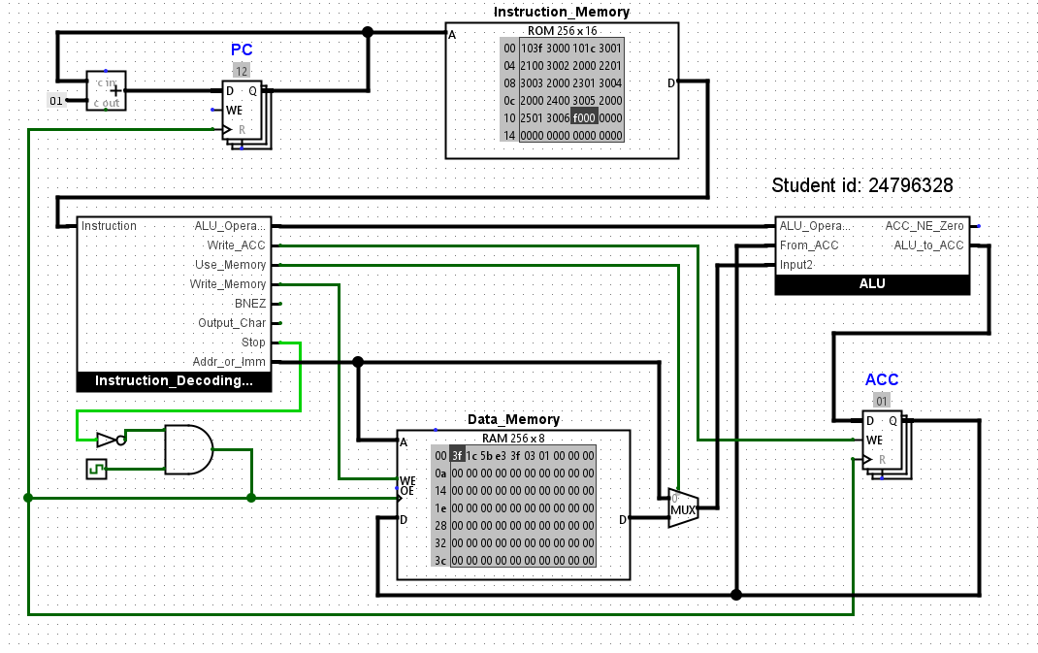
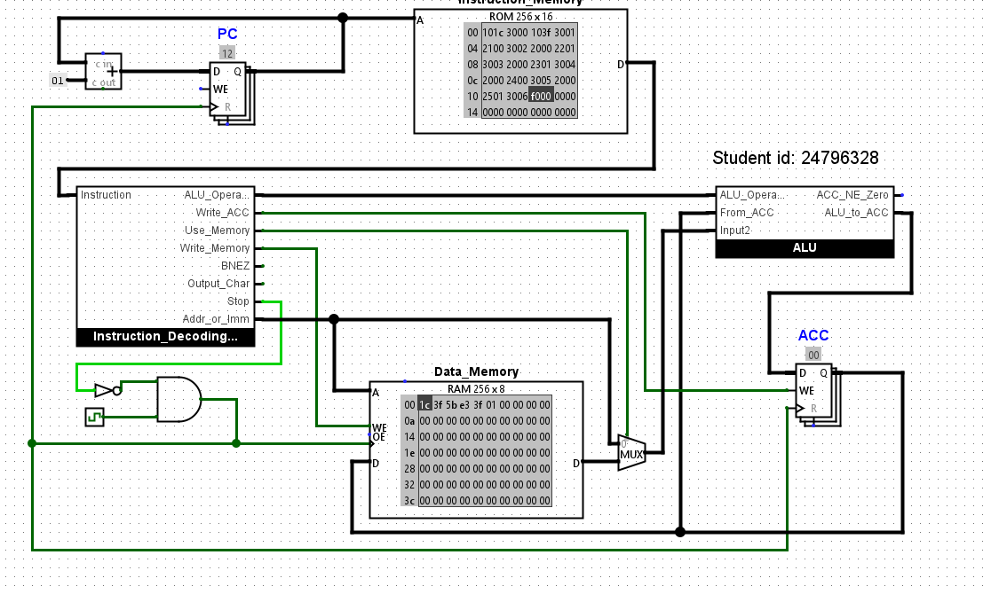
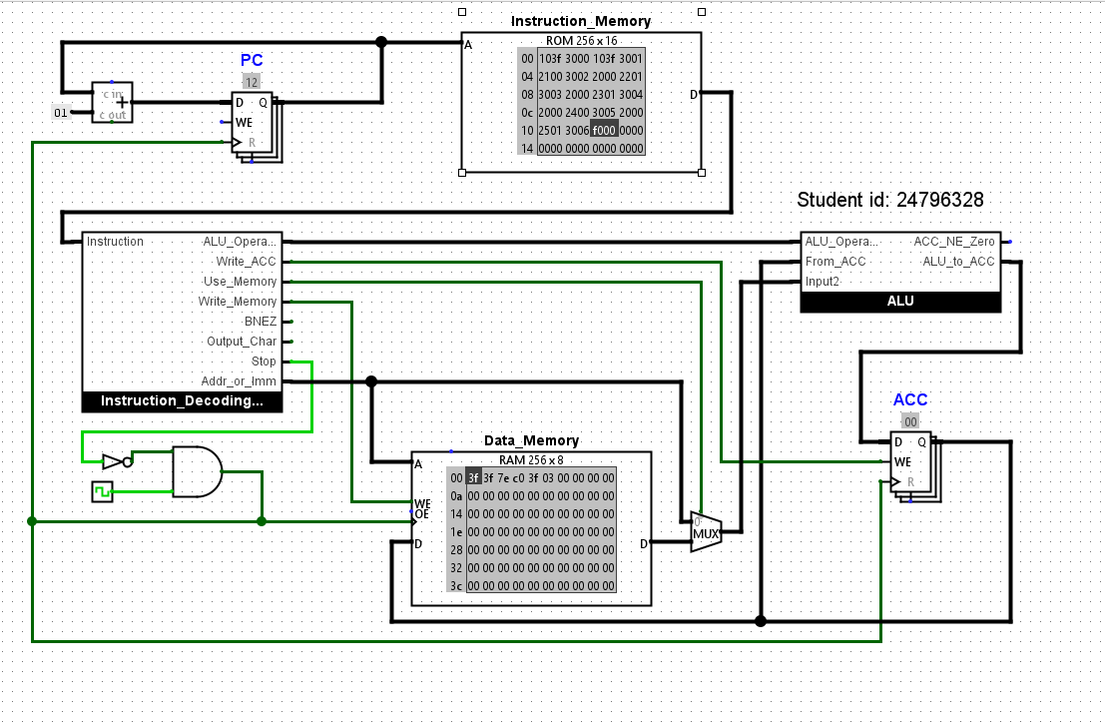

Result
In my test the first value is 3F and the second value is 1C, I’m comparing either to see which is larger and which is not resulting in the first value if larger to shift right. If not it will result in it outputting 00 as it wont shift since it isn’t greater. I predicted that if 3F is greater than 1C, it will shift right to 03 and then output 01, if 1C is being compared to 3F it will shift right to 01 and output 00 because it isn’t greater etc.

Explanation
I used a comparator to check whether the ACC value was greater than the second input. The comparator only gives a 1-bit output, but the rest of my ALU uses 8-bit signals, so I converted it to 8 bits. I did this by keeping the comparator output as the least significant bit and setting the other seven bits to 0. This means the ALU outputs 0x01 when the comparison is true and 0x00 when it is false.

Output Device

Test Data and Expected Result
v2.0 raw
48 69 20 41 62 64 69 72 61 68 6D 61 20 33 46
Hi Abdirhma 63

Test Program
v2.0 raw
2000 5000
2001 5000
2002 5000
2003 5000
2004 5000
2005 5000
2006 5000
2007 5000
2008 5000
2009 5000
200a 5000
200b 5000
200c 5000
200d 5000
f000

Circuit at end of program
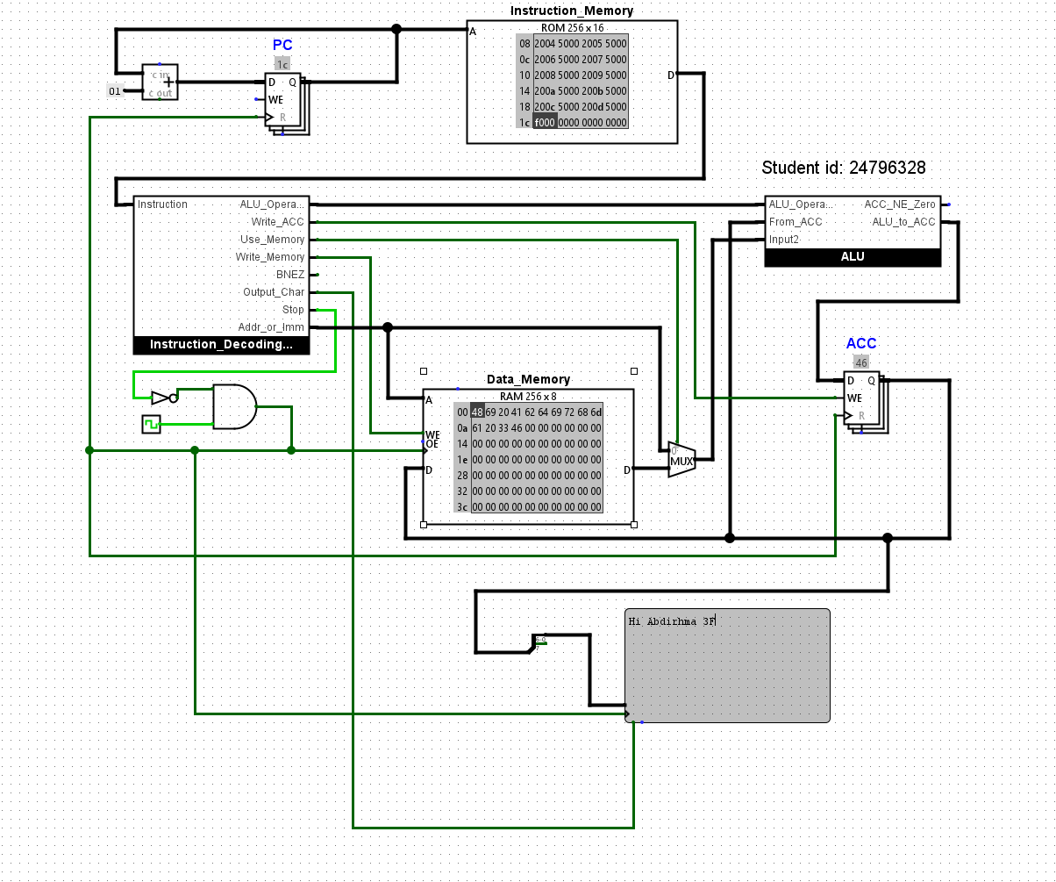

Result
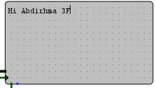
In this image it shows my TTY printing out what I predicted it would say, Hi Abdirhma 3F.

Explanation

ASCII is limited to 7 bits, meaning it can only represent 128 characters (IETF, 1969). This makes it unsuitable for non-English characters and symbols. To address this, extended ASCII uses 8 bits to add more characters, but it is not universally standardised, which causes compatibility issues (TechTarget, 2025). Unicode, especially UTF-8, solves this by supporting all ASCII characters and adding many more, allowing for characters from all writing systems (Mozilla, n.d.).

The research helped me understand why ASCII is limited and why Unicode (UTF-8) is now the standard, offering broader character support and better compatibility (IETF, 1969; TechTarget, 2025; Mozilla, n.d.).

Branch instruction

ALU circuit and testing
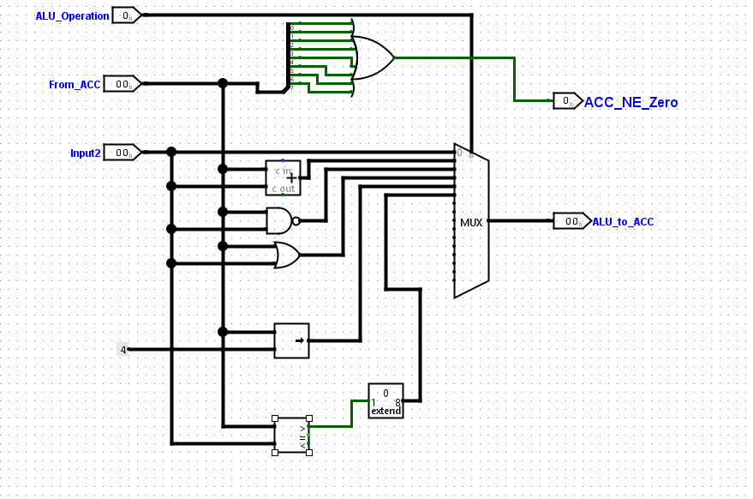

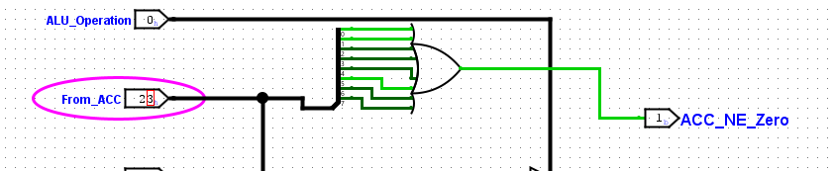

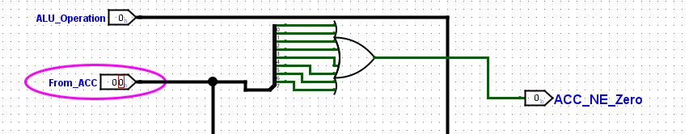

Test program
v2.0 raw
103F 3000 # put first value to ACC and store to 00
101C 3001 # put second value to ACC and store to 01
2000 # load value from address 00 into the ACC
2501 400f # set ACC value to 1 if data in address 0 is greater than the data in address 01
2000 3002 # load value from address 00 to ACC and store in address 02
2001 3000 # load value from address 01 to ACC and store in address 00
1000 3002 #set the value at address 02 in data memory to be 00
f000 # end program

Expected Results
I am expecting the program to branch to f000 if address 00 is greater than address 01 after that the program will end. if that happens it will store 3F in address 00. If address 00 is not greater than address 01, the program will continue and store address 00 value into 02, then it will load value from address 01 and store it into address 00 then set the value of address 02 in data memory 00. Then finally end program.

Results
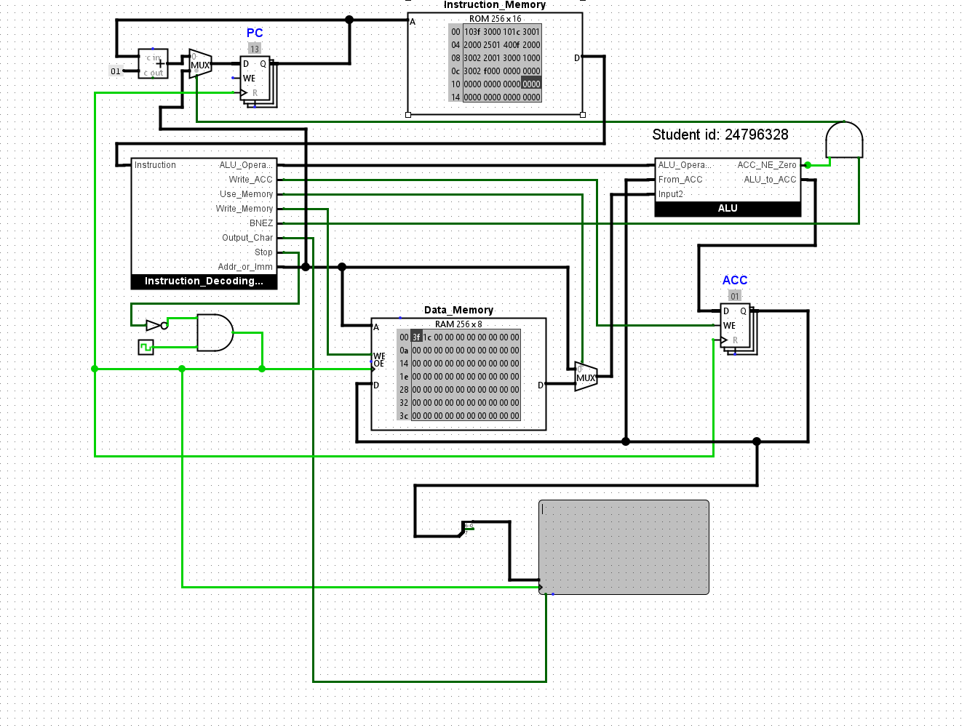
This is an image of the program running to test if 3F which is stored in address 00 is greater than 01 which then will lead to it branching to f000 which ends the program.
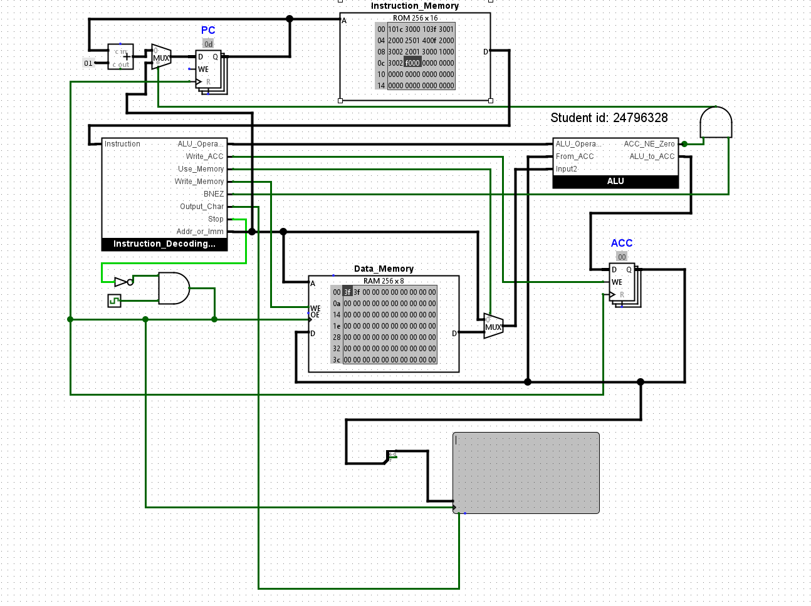
This is the second and third test. The second test was when I switched the two data with address 00 being 1C and address 01 being 3F, this resulting in my program continuing to run and then ended up stopping when it got to both being 3F as they are the same. The final test resulted in the program stopping because it wasn’t smaller or larger.

Explanation
For my branch instruction, I needed it to jump straight to the stop instruction (f000). I wrote my full program first, then counted the instruction addresses starting from 00 until I got to f000. In my program, f000 is at address 0F, so the branch instruction had to be 400F (4 = branch, 0 = no ALU op, 0F = target address). When the CPU runs the branch, it only jumps if BNEZ = 1 and ACC_NE_Zero = 1, so it loads the PC with 0F instead of doing PC+1.
From research, another common branch is BEQZ (branch if equal to zero). Shakti+1 That one would branch when the accumulator is zero. To add that to my CPU, I’d have a BEQZ output from the instruction decoder, then use a NOT on ACC_NE_Zero (so it becomes “ACC is zero”), and AND them together: BEQZ AND (NOT ACC_NE_Zero). That signal would drive the same PC-input multiplexer to select Addr_or_Imm.

Loop

Displaying Hex Output

Running Loop

Explanation

Game

RISC-V Assembly Language Programming

Test the existing program with minor adjustments

Starter Program
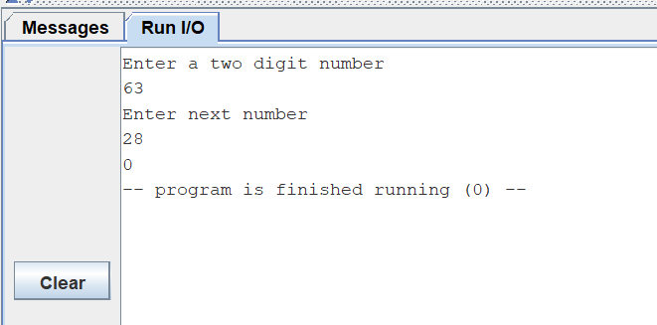

Expected Result
The total should be 91

Program code
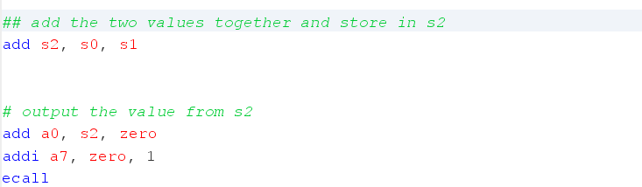

Result
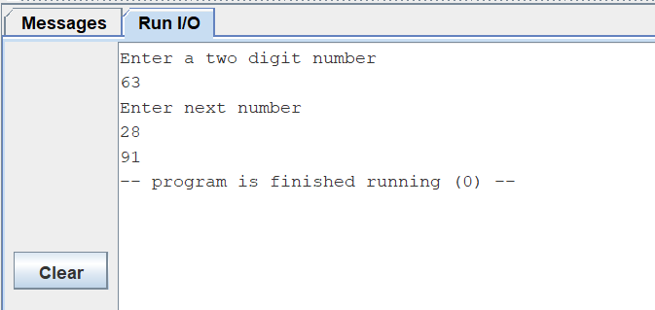
The total is 91 as expected

Improve the messages that the program outputs

Program Code
This is the code for the total message
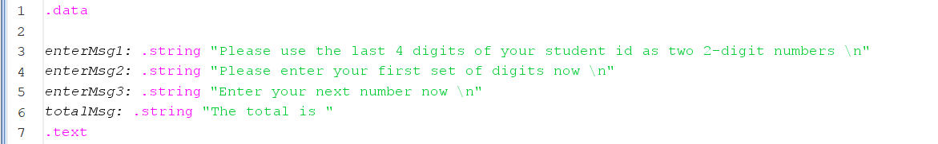

This is the lines of code following to show the total being called
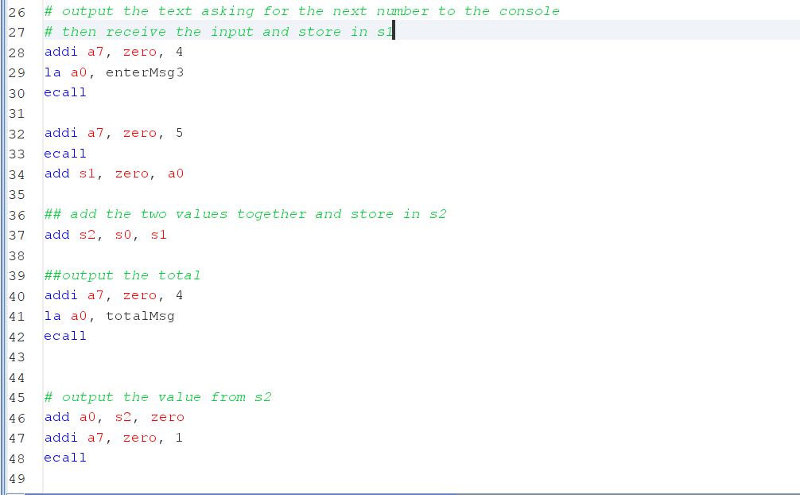

Results
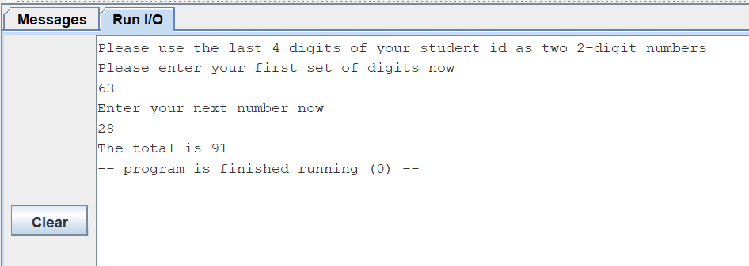

Explanation
Clear messages help the user interact and understand what to do and also how to use the programs functionality.

Enhancing the functionality of the program

Program Code
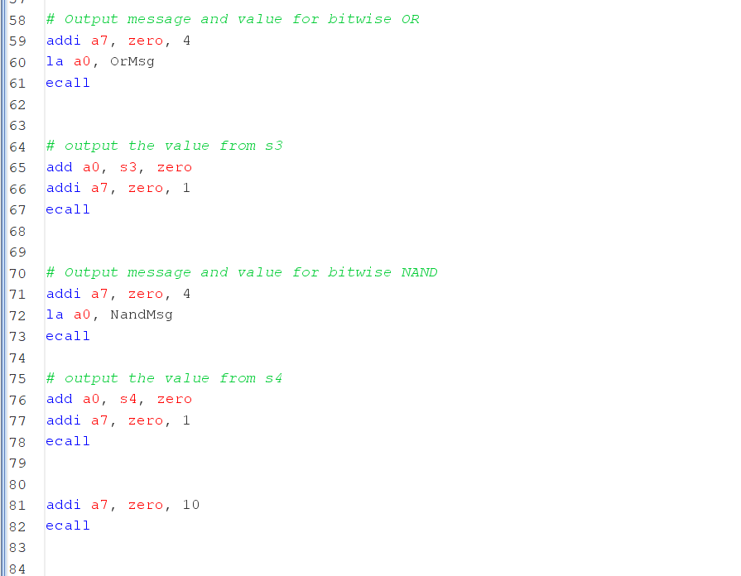

Expected Result
First number | 63 | 3F
Second number | 28 | 1C
Addition of original numbers | 91 | 5B
Bitwise OR of original numbers | 63 | 3F
Bitwise AND of original numbers (intermediate for NAND) | 28 | 1C
Bitwise NOT of previous result (giving NAND) | -29 | FFFFFFE3

Results

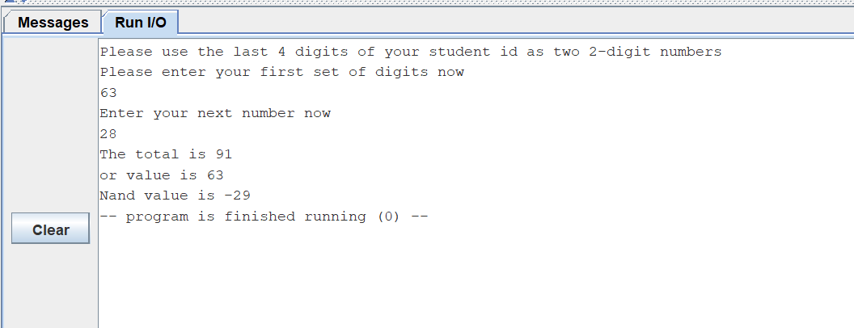

The results lined up with my prediction as shown In the table and Run I/O with all the values matching.

Explanation
First I started by doing the OR function which was or s3,s0,s1, after that I began the nand operation but the nand doesn’t have a one step function so I split it into 2. Firstly I did and function which was and t0, s0, s1. Which stored it into t0, then I did not s4, t0 which flipped it and turned it into a nand gate finally.

Comparison

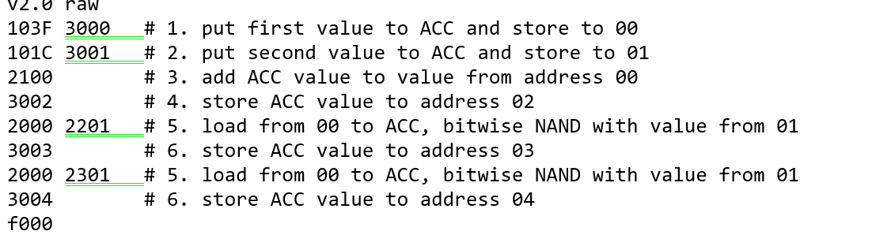

Logisim (CPU simulation): I wrote raw hex machine code (v2.0 raw). The program stores inputs in Data Memory [00] and [01], then uses opcodes to do ADD (2100 → store to [02]), NAND (2000 2201 → store to [03]) and OR (2000 2301 → store to [04]). I checked results by comparing the Data Memory hex values to my expected results (5B, E3, 3F).

RARS (RISC-V): I wrote assembly (add, or, and NAND as and then not) and checked correctness using Run I/O and register values. NAND prints as -29 because RARS uses 32-bit signed 2’s complement, so E3 becomes 0xFFFFFFE3. Value of research confirmed why NAND can show as a negative number in RARS even though the bit pattern matches the CPU simulation.

Adding a subroutine

Subroutine code
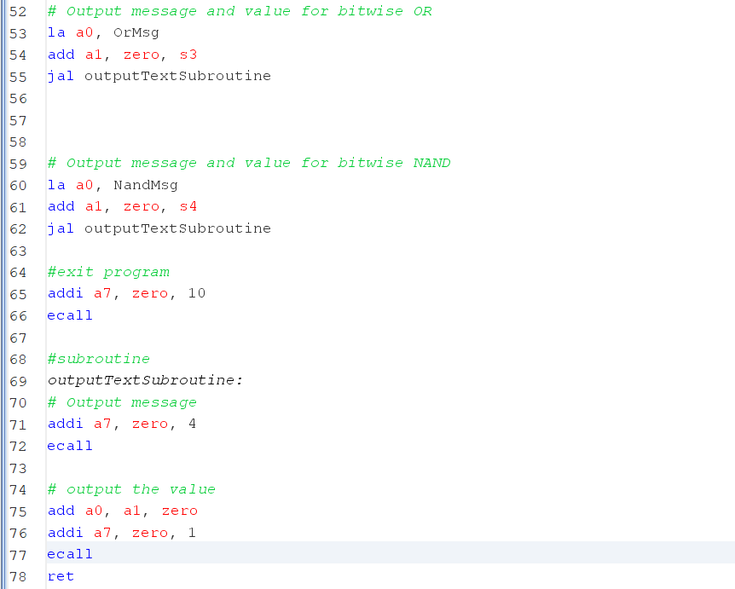

Result
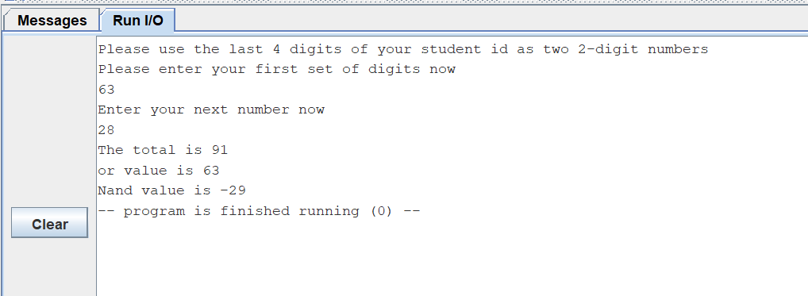

Explanation

Using subroutines in programming/risc v allows the user to break down long lines of code into more readable and neat lines of code which makes it easier to understand and follow through for them and also anyone who uses the code after them. It also allows them to debug it a lot easier in the long run. Jal stands for jump and link, Ret stands for return. I used jal to call the subroutine and jump to it, I used ret to end the subroutine and return back to the line underneath which here would be line 63.

Swapping Numbers

Program Code
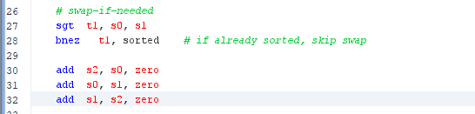

Expected Result
Test description | Value at s0 | Value at s1
First number bigger | 63 | 28 | 63, 28
First number smaller | 28 | 63 | 63, 28
Both numbers the same | 28 | 28 | 28 28

Result
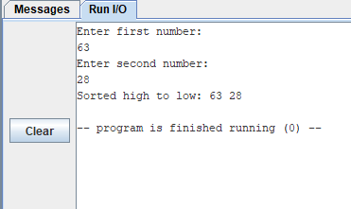
This was the first test and it was the same as my expected.

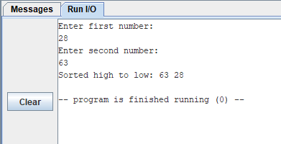
This was the second test and it was the same my expected.
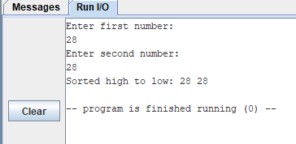
This was the last test and it was the same as my expected

Alternative approach
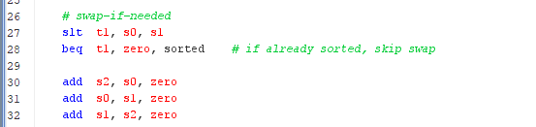

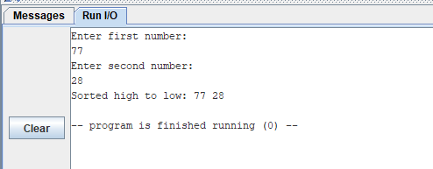
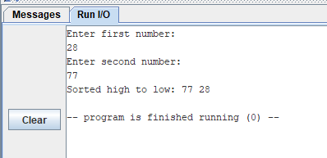
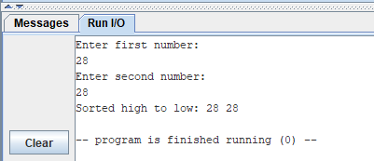

Explanation
The way I went with doing the swap code was by using the commands sgt and bnez which both stand for set greater than and branch if not equal to zero. In the alternative approach I used slt and beq instead which stands for branch if equal and set less than. I found that they were both the same difficulty and skill one was just dealing with it by larger than and the other was dealing with it the opposite way. They were pretty much the same similar way of code but they were different because slt is often a native instruction and sgt is often a pseudocode instruction.

Comparison

In my Logisim CPU, swapping meant moving values between Data Memory addresses using load/store steps and a temporary address so I didn’t overwrite anything. In RISC-V, the swap is simpler because the values are already in registers, so I just copy register-to-register. This can be shown throughout this task such as add s2, s0, zero, add s0, s1, zero, add s1, s2, zero. However in the cpu simulation you are using the command 3 to store a value to the acc. E.g 2000 2201, load from 00 to ACC, bitwise NAND with value from 01. This was what I understood from my experience with the work done and I couldn’t find references to research from.

Counting down with a loop

Loop Code

Results

Alternative approach

Explanation

Making use of arrays

Pseudocode

Expected Results

Result

Explanation

Comparison

Designing a game

References

IETF (1969) RFC 20: ASCII format for network interchange. Available at: https://datatracker.ietf.org/doc/html/rfc20. Accessed: 2 January 2026.
Mozilla (n.d.) UTF-8 - Glossary. MDN Web Docs. Available at: https://developer.mozilla.org/en-US/docs/Glossary/UTF-8. Accessed: 2 January 2026.
TechTarget (2025) ASCII (American Standard Code for Information Interchange). Available at: https://www.techtarget.com/whatis/definition/ASCII-American-Standard-Code-for-Information-Interchange. Accessed: 2 January 2026.

University of Delaware (n.d.) Branch Equal to Zero. Available at: (online). Accessed: 5 January 2026. EECIS
Waterman, A. et al. (2016) The RISC-V Instruction Set Manual, Volume I: User-Level ISA (Version 2.1). University of California, Berkeley. Available at: (online). Accessed: 5 January 2026.

Appendix A: The CPU Simulation Code
The code within this section needs to be as plain text which could be copied and pasted into another file to test your circuit.

This is the code from task 1.1

v2.0 raw
103F 3000 # 1. put first value to ACC and store to 00
101C 3001 # 2. put second value to ACC and store to 01
2100 # 3. add ACC value to value from address 00
3002 # 4. store ACC value to address 02
2000 2201 # 5. load from 00 to ACC, bitwise NAND with value from 01
3003 # 6. store ACC value to address 03
2000 2301 # 5. load from 00 to ACC, bitwise NAND with value from 01
3004 # 6. store ACC value to address 04
f000

this is the code from task 1.3

v2.0 raw
103F 3000 # 1. put first value to ACC and store to 00
101C 3001 # 2. put second value to ACC and store to 01
2100 # 3. add ACC value to value from address 00
3002 # 4. store ACC value to address 02
2000 2201 # 5. load from 00 to ACC, bitwise NAND with value from 01
3003 # 6. store ACC value to address 03
2000 2301 # 5. load from 00 to ACC, bitwise NAND with value from 01
3004 # 6. store ACC value to address 04
f000

This is the code from task 1.4

v2.0 raw
103F 3000 # 1. put first value to ACC and store to 00
101C 3001 # 2. put second value to ACC and store to 01
2100 # 3. add ACC value to value from address 00
3002 # 4. store ACC value to address 02
2000 2201 # 5. load from 00 to ACC, bitwise NAND with value from 01
3003 # 6. store ACC value to address 03
2000 2301 # 5. load from 00 to ACC, bitwise NAND with value from 01
3004 # 6. store ACC value to address 03
2000 2400 # 5. load from 00 to ACC, binary shift to the right
3005 # 6. store ACC value to address 05
2000 2501 # 5. load from 00 to ACC, compare with value from 01
3006 # 6. store ACC value to address 06
f000

this is the code from task 1.5

v2.0 raw
2000 5000
2001 5000
2002 5000
2003 5000
2004 5000
2005 5000
2006 5000
2007 5000
2008 5000
2009 5000
200a 5000
200b 5000
200c 5000
200d 5000
f000

this is the code from task 1.6

v2.0 raw
103F 3000 # put first value to ACC and store to 00
101C 3001 # put second value to ACC and store to 01
2000 # load value from address 00 into the ACC
2501 400f # set ACC value to 1 if data in address 0 is greater than the data in address 01
2000 3002 # load value from address 00 to ACC and store in address 02
2001 3000 # load value from address 01 to ACC and store in address 00
1000 3002 #set the value at address 02 in data memory to be 00
f000 # end program

Appendix B: The RISC-V Assembly Language Code
The code within this section needs to be as plain text which could be copied and pasted into RARS to test your work. You may include more subheadings.

Tasks 2.1 to 2.3
.data

enterMsg1: .string "Please use the last 4 digits of your student id as two 2-digit numbers \n"
enterMsg2: .string "Please enter your first set of digits now \n"
enterMsg3: .string "Enter your next number now \n"
totalMsg: .string "The total is "
OrMsg : .string "or value is "
NotMsg: .string " Not value is "
AndMsg: .string "And value is "
.text

###
# output the first instruction text to the console
addi a7, zero, 4
la a0, enterMsg1
ecall

# output the second instruction text to the console
addi a7, zero, 4
la a0, enterMsg2
ecall

# read an integer from keyboard input and store in s0
addi a7, zero, 5
ecall
add s0, zero, a0

# output the text asking for the next number to the console
# then receive the input and store in s1
addi a7, zero, 4
la a0, enterMsg3
ecall

addi a7, zero, 5
ecall
add s1, zero, a0

## add the two values together and store in s2
add s2, s0, s1

or s3, s0, s1
and t0, s0, s1
not s4, t0

##output the total
addi a7, zero, 4
la a0, totalMsg
ecall

# output the value from s2
add a0, s2, zero
addi a7, zero, 1
ecall

# Output message and value for bitwise OR
addi a7, zero, 4
la a0, OrMsg
ecall

# output the value from s3
add a0, s3, zero
addi a7, zero, 1
ecall

# Output message and value for bitwise NAND
addi a7, zero, 4
la a0, NotMsg
ecall

# output the value from s4
add a0, s4, zero
addi a7, zero, 1
ecall

addi a7, zero, 10
ecall

Task 2.4 Including a subroutine
.data

enterMsg1: .string "Please use the last 4 digits of your student id as two 2-digit numbers \n"
enterMsg2: .string "Please enter your first set of digits now \n"
enterMsg3: .string "Enter your next number now \n"
totalMsg: .string "The total is "
OrMsg : .string "\nor value is "
NandMsg: .string "\nNand value is "
.text

###
# output the first instruction text to the console
addi a7, zero, 4
la a0, enterMsg1
ecall

# output the second instruction text to the console
addi a7, zero, 4
la a0, enterMsg2
ecall

# read an integer from keyboard input and store in s0
addi a7, zero, 5
ecall
add s0, zero, a0

# output the text asking for the next number to the console
# then receive the input and store in s1
addi a7, zero, 4
la a0, enterMsg3
ecall

addi a7, zero, 5
ecall
add s1, zero, a0

## add the two values together and store in s2
add s2, s0, s1

or s3, s0, s1
and t0, s0, s1
not s4, t0

##output the total
la a0, totalMsg
add a1, zero, s2
jal outputTextSubroutine

# Output message and value for bitwise OR
la a0, OrMsg
add a1, zero, s3
jal outputTextSubroutine

# Output message and value for bitwise NAND
la a0, NandMsg
add a1, zero, s4
jal outputTextSubroutine

#exit program
addi a7, zero, 10
ecall

#subroutine
outputTextSubroutine:
# Output message
addi a7, zero, 4
ecall

# output the value
add a0, a1, zero
addi a7, zero, 1
ecall
ret

Task 2.5 Swapping numbers
.data
msg1: .string "Enter first number:\n"
msg2: .string "Enter second number:\n"
outmessage: .string "Sorted high to low: "
nl: .string "\n"

.text
.globl main
main:
# read s0
addi a7, zero, 4
la a0, msg1
ecall
addi a7, zero, 5
ecall
add s0, a0, zero

# read s1
addi a7, zero, 4
la a0, msg2
ecall
addi a7, zero, 5
ecall
add s1, a0, zero

# swap-if-needed
sgt t1, s0, s1
bnez t1, sorted # if already sorted, skip swap

add s2, s0, zero
add s0, s1, zero
add s1, s2, zero

sorted:
# output message
addi a7, zero, 4
la a0, outmessage
ecall

# print s0
addi a7, zero, 1
add a0, s0, zero
ecall

# print separator as single character (space)
addi a7, zero, 11
addi a0, zero, 32
ecall

# print s1
addi a7, zero, 1
add a0, s1, zero
ecall

# newline
addi a7, zero, 4
la a0, nl
ecall

# exit
addi a7, zero, 10
ecall

Alternative approach

.data
msg1: .string "Enter first number:\n"
msg2: .string "Enter second number:\n"
outmessage: .string "Sorted high to low: "
nl: .string "\n"

.text
.globl main
main:
# read s0
addi a7, zero, 4
la a0, msg1
ecall
addi a7, zero, 5
ecall
add s0, a0, zero

# read s1
addi a7, zero, 4
la a0, msg2
ecall
addi a7, zero, 5
ecall
add s1, a0, zero

# swap-if-needed
slt t1, s0, s1
beq t1, zero, sorted # if already sorted, skip swap

add s2, s0, zero
add s0, s1, zero
add s1, s2, zero

sorted:
# output message
addi a7, zero, 4
la a0, outmessage
ecall

# print s0
addi a7, zero, 1
add a0, s0, zero
ecall

# print separator as single character (space)
addi a7, zero, 11
addi a0, zero, 32
ecall

# print s1
addi a7, zero, 1
add a0, s1, zero
ecall

# newline
addi a7, zero, 4
la a0, nl
ecall

# exit
addi a7, zero, 10
ecall

Task 2.6 Loop

Task 2.7 Array

Task 2.8 Creating a console based game

Stage 1

Stage 2

Stage 3

Appendix C: Use of Generative AI
In this section, name the tool used and paste the full chat prompts and outputs used towards responses for this assessment.

